

**What is Agile?**

It is a Software Development Model alternate to other models like Waterfall, Spiral, V and V etc.

**Manifesto for Agile Software Development**

**Individuals and interactions** over processes and tools.  
**Working software** over comprehensive documentation.  
**Customer collaboration** over contract negotiation.  
**Responding to change** over following a plan.

That is, while there is value in the items on the right, we value the items on the left more.

**Different Agile Methodologies**

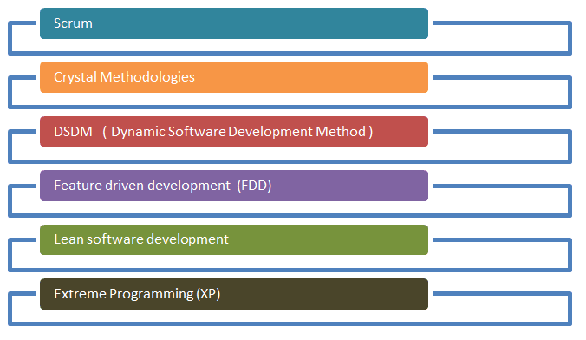

**Widely Used Agile Methodology across the IT industries**

**Scrum** is the most widely used agile methodology

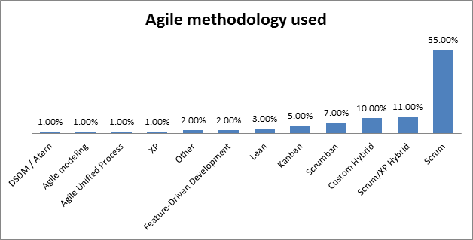

**Introduction to Scrum**

Scrum is one of the most popular frameworks for implementing agile. So popular, in fact, that many people think scrum and agile are the same thing. (They're not.) Many frameworks can be used to implement agile, but scrum has a unique flavour. It's also a great way for teams to get started with agile.

**What Scrum is not?**

It is not a model like waterfall where each phase must be completed before you go to the next phase and the end product is available to be seen by the product owner only at the end of one year.

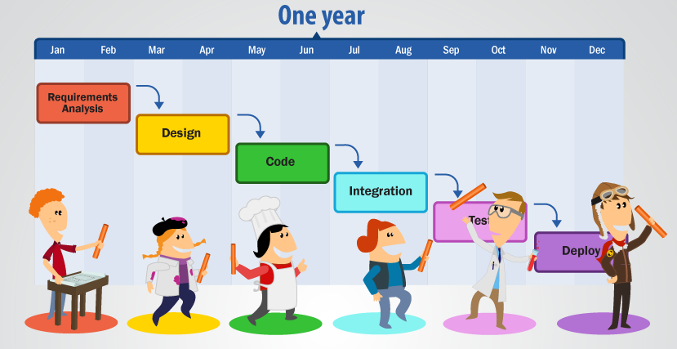

**What is Scrum?**

Scrum is an Agile Methodology in which the project is broken into small pieces or increments called sprints where the expected outcome from each sprint is a working software.

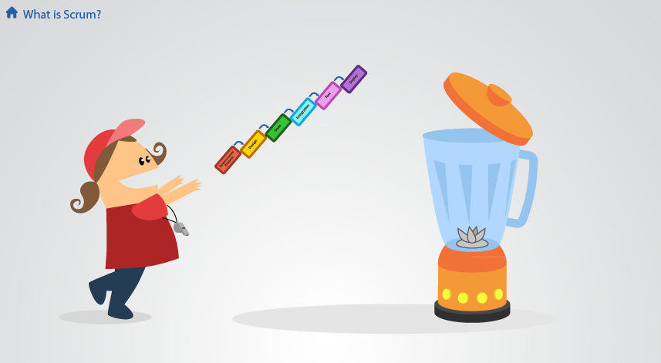 

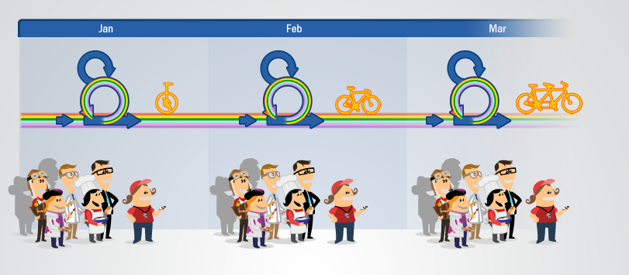

**Scrum Elements**

1. Roles
2. Artifacts
3. Meetings

**Roles**

There are 3 main roles in a scrum methodology

1. Product Owner
2. Scrum Development Team
3. Scrum Master

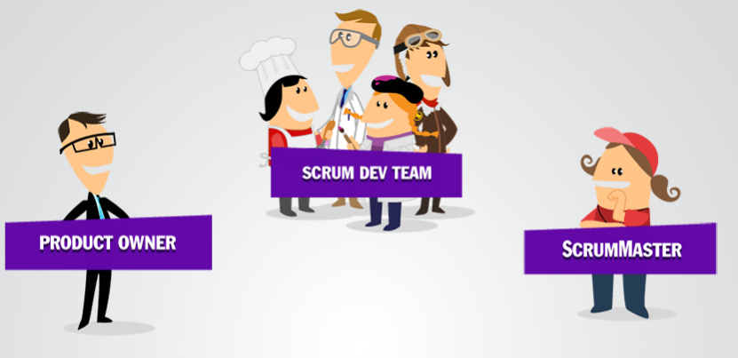

**What is the role of a Product Owner?**

The [Scrum](https://www.mountaingoatsoftware.com/agile/scrum) product owner is typically a project's key stakeholder. Part of the product owner responsibilities is to have a vision of what he or she wishes to build, and convey that vision to the scrum team.

**What is the role of a Scrum Master?**

The Scrum Master is responsible for making sure a Scrum team lives by the values and practices of [Scrum](https://www.mountaingoatsoftware.com/agile/scrum). The Scrum Master can also be thought of as a *process owner* for the team, creating a balance with the project's product owner.

The Scrum Master does anything possible to help the team perform at their highest level. This involves removing any impediments to progress, facilitating meetings, and doing things like working with the product owner to make sure the product is in good shape and ready for the next sprint.

**What is Scrum Development team?**

A Scrum team in a [Scrum](https://www.mountaingoatsoftware.com/agile/scrum) environment does not include any of the traditional software engineering roles such as programmer, designer, tester or architect. Everyone on the project works together to complete the set of work they have collectively committed to complete within a sprint.

Typically the scrum team size ranges from 5-9 people.

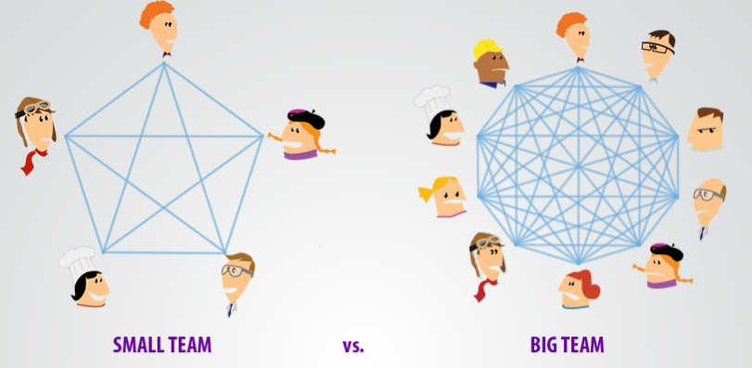

**Artifacts**

1. Product Backlog
2. Sprint Backlog

**Product Backlog**

The product backlog in [Scrum](https://www.mountaingoatsoftware.com/agile/scrum) is a prioritized features list, containing short descriptions of all functionality desired in the product. When applying Scrum, it's not necessary to start a project with a lengthy, upfront effort to document all requirements. Typically, a Scrum team and its product owner begin by writing down everything they can think of for backlog prioritization. This product backlog is almost enough for the first sprint. The Scrum product backlog is then allowed to grow and change as more is learned about the product and its customers. Product Backlog items are prioritized before we start the sprint cycles.

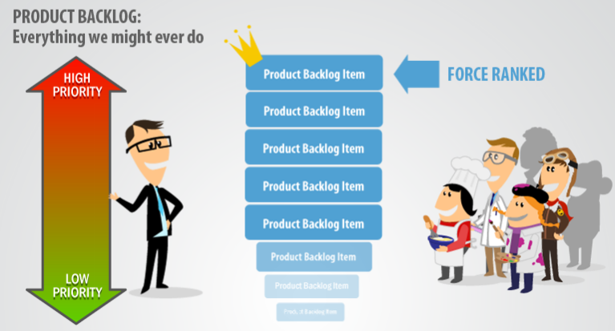

**Sprint Backlog**

Everything that we have agreed to complete in the current sprint is called as Sprint Backlog.

The sprint backlog is a list of tasks identified by the Scrum team to be completed during the Scrum sprint. During the sprint planning meeting, the team selects some of product backlog items, usually in the form of user stories, and identifies the tasks necessary to complete each user story.

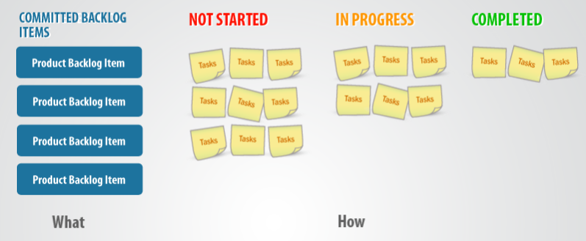

**Meetings**

1. Sprint Planning Meeting
2. Daily Scrum
3. Sprint Review Meeting
4. Sprint Retrospective Meeting
5. Backlog Refinement Meeting

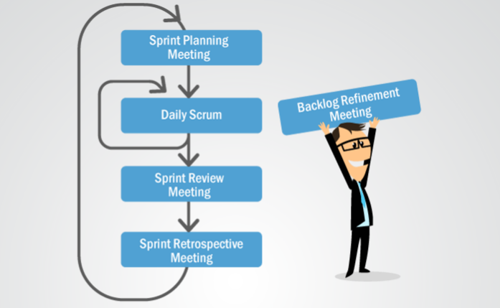

**Sprint Planning Meeting**

It is conducted at the beginning of each sprint. Its duration is typically 2-4 hours. During the sprint planning meeting, the product owner describes the highest priority features to the team. The team asks enough questions that they can turn a high-level user story of the product backlog into the more detailed tasks of the sprint backlog.

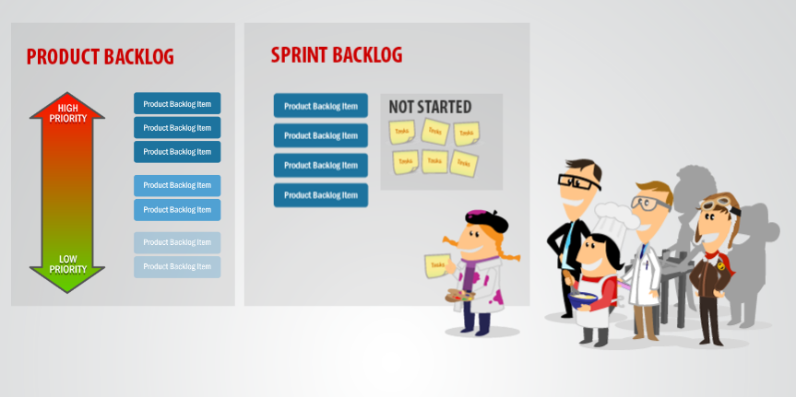

**Daily Scrum Meeting**

It is conducted on each day of Sprint. Ideally, a daily scrum meeting is held in the morning, as it helps set the context for the day's work and discuss what was done on the previous day. These scrum meetings are strictly time-boxed to 15 minutes. This keeps the discussion brisk but relevant.

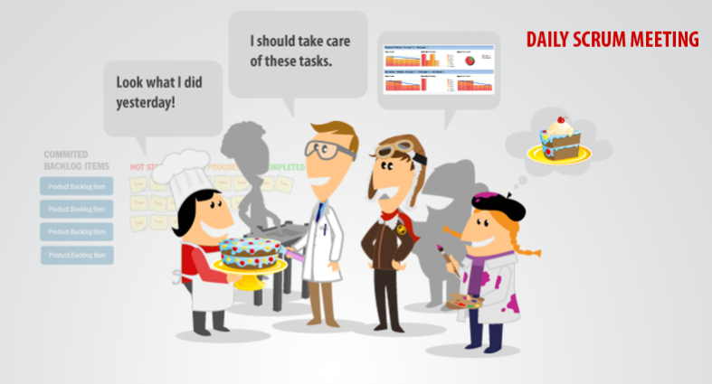

**Sprint Review Meeting**

In [Scrum](https://www.mountaingoatsoftware.com/agile/scrum), each sprint is required to deliver a potentially shippable product increment. This means that at the end of each sprint, the team has produced a coded, tested and usable piece of software. So at the end of each sprint, a sprint review meeting is held. During this meeting, the Scrum team shows what they accomplished during the sprint.

During the sprint review, the project is assessed against the sprint goal determined during the sprint planning meeting.

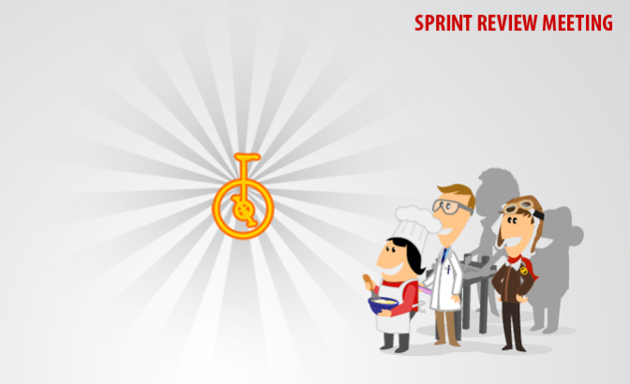

**Sprint Retrospective Meeting**

The Scrum team should set aside dedicated period at the end of each sprint to reflect on how they are doing and to find ways to improve. This occurs during the sprint retrospective. This meeting typically takes 1-2 hours. The sprint retrospective is the last thing done in a sprint. It can be done after sprint review meeting. The entire team, including both the Scrum Master and the product owner should be part of this meeting.

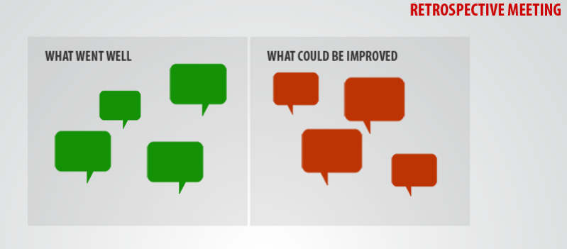

**Backlog Refinement Meeting**

The Backlog Refinement Meeting is also called Product Backlog Grooming, Backlog Estimation, and even Story Time. The purpose of the Backlog Refinement Meeting is to help the Product Owner get the top of the Product Backlog ready for the next Sprint Planning Meeting.

Backlog refinement includes estimation of effort, clarification of requirements, and decomposition of large Product Backlog Items (often called “epics”) into smaller ones (such as “user stories”).